# PREOWNED CARS AND BIKES SYSTEM

* Title :- Preowned Cars and Bikes System

* Project Description :-

Through this platform users will be able to buy and sell preowned Cars and Bikes seamlessly and effortlessly through trusted listings,Convenient search tools,transparent pricing,userfriendly interfaces.For people Who want to sell their vehicle,this platform allows

to create detailed listing of their vehicle with photos,description,ownership records,vehicle history,maintainance records,condition,and set a competitive price based on value of vehicle in market and its Condition.This platform will help sellers to reach potential buyers and receive inquiries and messages from interested Buyers.Similarly this platform will also help the people who are looking for a preowned vehicle.The Buyers will be able to easily find the vehicle according to their requirements.

* WHY THIS TOPIC ?

In todays time the prices of new cars and Bikes are increasing day by day. So lots of people go for 2nd hand vehicle option.However the traditional process of buying and selling preowned cars/bikes through dealership can be a frustrating and time-consuming process. Because of limited options,lack of transparency and need to physically visit multiple dealers to find right vehicle or buyer.There are many websites available on the internet.But this one will have various features like,listing modification interface,providing vehicle history reports,virtual tour experience,Instant messaging,Car Inspection service,user review and rating interface.So the goal is to develop a system on which people can easily and seamlessly sell and buy both used cars/bikes with Confidence.

* OBJECTIVES :-
  1. To eliminate the old method of visiting the 2nd hand vehicle dealers and examining the vehicle.
  2. To provide a platform that will help sellers to reach a wide rance of potential buyers.
  3. To provide advance search filters for searching vehicles according specifications,brand,model,etc.
  4. To provide detailed listing that will give information,high-quality images,features,etc.
  5. To provide transparent pricing information without including any hidden charges or fees.
  6. To provide direct communication between Buyers and Sellers.
  7. To provide user-friendly interface for sellers to create and manage Ads of their vehicles.
  8. To provide Inspectionist finder tab for inspection of vehicles.

* SCOPE :-

The scope of the system is to provide a platform that directly connects Buyers and Sellers across India and help them for selling and buying cars/bikes.

* METHODOLOGY :-

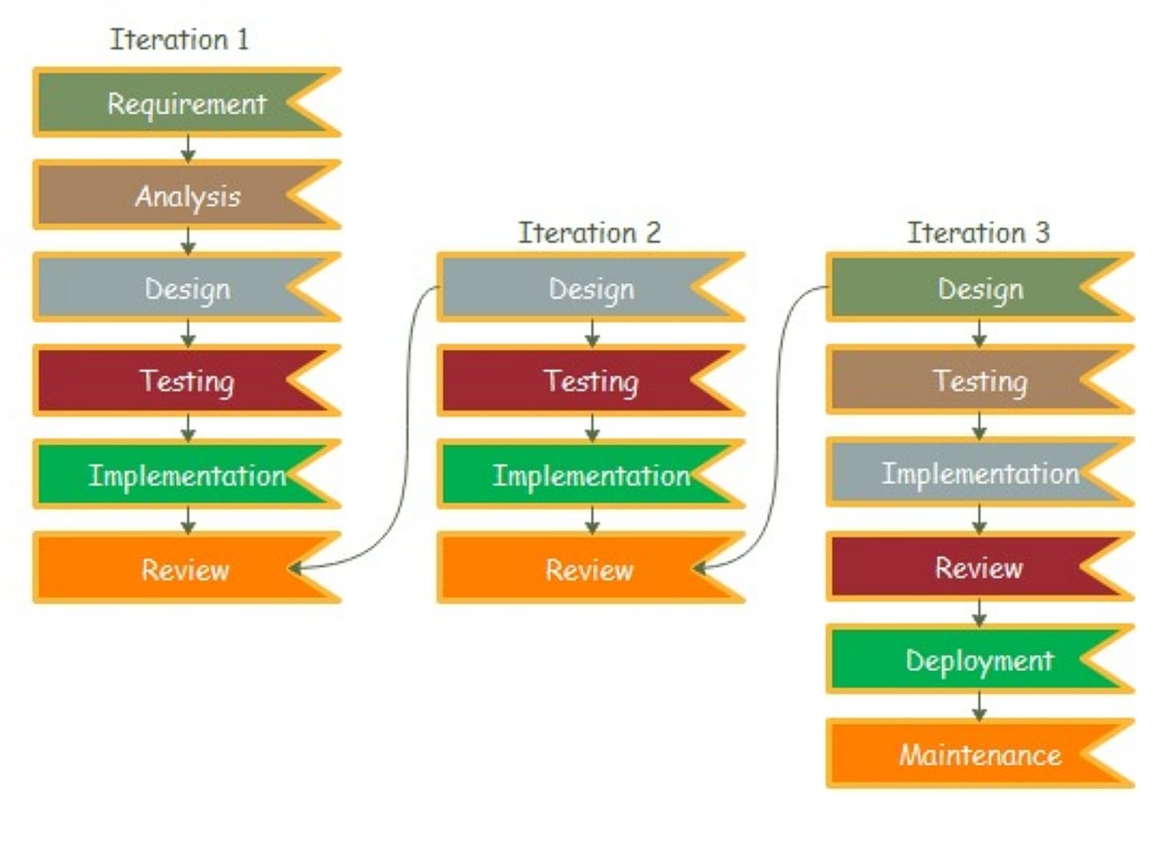For developing this system I would use an iterative approach. Because feedback of previous iteration will help to improve the next iteration.

* PROPOSED ARCHITECTURE :-

For developing this project iam using 2-tier architecture i.e divide and organize the website into 2-main parts :-

* + - 1. Client Side :- This part will contain all the user interfaces that will run on users device and take inputs from users.
      2. Server Side :- This part will contain all the logic parts and data storage of the

website,Thechanges will be done in this part when user de modification in frontend to do so logics are used present.

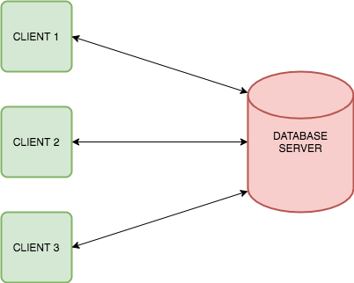

* REQUIREMENTS :-

1. Software Requirements :-

* Front-End :- HTML,CSS,JavaScript,BootStrap,Ajax,Jquery.
* Back-End :- PHP
* DataBase :- MYSQL

2. Hardware Requirements :-

* Processor :- AMD Ryzen 5200H or Intel i3 or newer
* Ram :- 2 GB – 4 GB
* Hard-Disk :- 256 GB SSD
* Monitor :- 1200 x 800 screen resolution

3. PLATFORM :-

* Visual Studio Code

* CONTRIBUTION :-

The website will help and assist users for buying and selling preowned vehicles.The sellers can easily make their vehicle listing on website and reach potential buyers.Similarly the Buyers can use search filters,user friendly interface for finding the best vehicle according to their requirements and providing direct communication between buyers and sellers. This system helps the buyers and sellers to view and list the vehicles online rather than visiting the vehicle location physically.

* CONCLUSION :-

This system eliminates the old method of physically visiting the place where the vehicle is standing and examining the vehicle or visiting the 2nd hand car,bike dealer for selling the vehicle at desired price. This platform connects both buyers and sellers directly to provide a seamless and trustful experience and save their time and energy.whith this platform the users can buy and sell preowned vehicles easily and effortlessly.

# CHAPTER 1 :- INTRODUCTION

* BACKGROUND :-

When it comes to purchasing or selling pre-owned vehicles, the traditional method of physically visiting a second-hand dealer can be inconvenient and timeconsuming. There are Various websites available on the internet such as, Car Dekho,Bike Dekho, CarWale, Car Trade, etc. These websites helps users. for Buying and Selling their vehicles online. These websites provides vehicle details, photographs which helps user for making decisions. But these existing websites have various issues like,lack of maintaining records of sold vehicles, not providing images and videos of damaged parts if any, unreliable inspection options, presence of fake Ads, absence of direct Communication between Buyers and Sellers. Due to these reasons the overalluser experience get's affected.

* OBJECTIVE :-
  1. The website will have search filters which Buyers can use for shortlisting the vehicles Ads according to their requirements.

* 1. The seller will get a user-friendly interface for creating and managing Ads of their vehicles.

* 1. To provide Virtual experience of vehicle through high quality images and Videos.

* 1. To provide all the details in listings like, vehicle history reports, owner experience with vehicle, maintainance records, description of damages with images if any,features specifications,etc.

* 1. To provide transparent pricing information without including any hidden charges or fees.

* 1. website will have inspectionist finder tab for inspection of cars.

* 1. To provide direct communication between Buyers and Sellers by exchanging their contacts or by direct messaging.

* PURPOSE :-

The purpose of this 2nd Hand cars and Bikes website is to provide individuals a convenient and efficient platform for purchasing and selling pre-owned vehicles. The aim of website is to simplify the process of Buying and selling by providing userfriendly interfaces. through which the Buyers can browse through wide range of vehicles and similarly the Sellers can easily list their vehicles on website and reach potential Buyers. Overall this website is a platform that helps for Buying and selling vehicles according to users Comfort and Convenience.

* SCOPE :-

The scope of the website is to provide a Platform for connecting Buyers and sellers and help them for Buying and selling cars/Bikes all over India.

* APPLICABILITY :-

This website will be accessible for all the people of India and this website will guide and help the people those who want to Purchase a pre-owned vehicle effortlessly and without wasting time. Similarly it will

also help the people those who want to sell their vehicles.

# CHAPTER 2 :- SURVEY OF TECHNOLOGY

* Front-End Languages :-

* Html
* CSS
* JavaScript
* jQuery
* Tailwind CSS
* AJAX

HTML5 :- Hypertext Markup Language, is a powerful tool used in web development, offering a wide array of features that enhance both functionality and aesthetics. Its primary function is to structure and present content on the internet, providing a standardized format that web browsers can interpret and display to users. HTML5 is commonly used to create static web pages, dynamic web applications, and interactive multimedia content. With its semantic markup, HTML5 enables developers to organize content in a meaningful and accessible way, improving search engine optimization and usability.

CSS :- Cascading Style Sheets (CSS) is a component of web design. It is responsible for the visual presentation and layout of web pages. It works with HTML to define the appearance of elements on a webpage, including fonts, colors, spacing, and positioning. CSS allows to create a separate .css file making it easier to maintain and update the design of a website. By applying CSS rules to HTML elements consistent and appealing visual effects across multiple pages can be applied. CSS offers a wide range of capabilities, including responsive design for optimizing layouts across different devices, animations and transitions for adding interactivity, and advanced styling techniques such as flexbox and grid for element positioning. CSS empowers to create attractive and user-friendly websites by controlling the presentation of web content.

JavaScript :- Javascript is a dynamic programming language. It is a light weight and most commonly used language as a part of web pages, whose implementation allow client-side script to interact with the user and make dynamic pages. javascript can update and change both HTML and CSS.

Jquery :- jQuery is one of the earliest front and framework and despite its launch date it continuous to be relevant in today's tech World. This framework offers are up to use and simplicity along with minimising the used to write the extensive JavaScript codes. There are also an extensive jQuery community that developers can rely on for solution.

Tailwind CSS :- Tailwind CSS is a utility-first CSS framework that streamlines web development by providing a comprehensive set of pre-designed, low-level utility classes. Developers can efficiently build user interfaces by applying these classes directly in the HTML, enabling quick and flexible styling without adhering to a predefined design. Tailwind promotes readability, maintainability, and a rapid development workflow.

AJAX :- Ajax is a set of web development techniques that allows web applications to send and receive data asynchronously without reloading the entire page. Ajax enables creation of more dynamic and interactive user experiences, it makes web applications feel more responsive.

* Back-End Languages :-

* PHP
* Node.js
* Java
* C#
* GO

PHP :- PHP is hypertext preprocessor is widely used opensource general purpose scripting language. PHP is a server-side scripting language that is used to interact with the database. PHP script can only be interpreted on a server that has PHP installed. It is used for web development and it can also be embedded into HTML.

Node.js :- It is a open-source cross-platform runtime environment that allows developer to run the Javascript on Server-side. It is a light weight and efficient for network applications. The Node Package Manager (NPM) provides access to a vast repository of libraries and modules, which accelerates the development process.

JAVA :- Java is a highly popular object-oriented language known for it's portability and robustness. Frameworks like springBoot provide a comprehensive environment for building applications with complex logics. The cross-platform capability makes Java an attractive choice for developing large applications. Framework like springBoot streamlines backend development by providing tools for developing secure, scalable, maintainable applications.

C# :- C# is a powerful, object-oriented programming language developed by Microsoft, used for backend development. due to it's versatility, efficiency, and Integration with .NET Framework It provides highperformance, cross-platform framework for building modern web applications.

Go :- Go is also known as Golang, is a language by Google it is known for its simplicity concurrency features and efficiency. Go is often used for building high performance web applications.

# ▪ Database :-

* My SQL
* MongoDB

My SQL :- MySQL is widely used open-source relational database management system (RDBMS) developed by oracle corporation known for its reliability, performance, easy-to-use. It consists of structured query language (SQL) for accessing and managing the data stored within it's database. my sql supports a variety of platforms like, windows, Macos, Linux and UNIX. MySQL's architecture allows for scalability, and it supports large databases with large records.

MongoDB :- MongoDB is a popular, open-source NoSQL database known for it's high performance, scalability, and flexibility. MongoDB stores data in flexible manner, which allows for varying structures and inclusion of nested data. The document-oriented approach makes it well-suited for handling large scale unstructured data. It does not store or retrieve data in form of tables. It also supports replication by keeping multiple copies of data across different Nodes.

• WHY THESE LANGUAGES :-

The website will be developed using HTML, CSS, Tailwind

CSS, javascript, PHP, MYSQL, Jquery, AJAX. To create

dynamic and responsive user experience. HTML will provide the foundational structure of webpages, while CSS and Tailwind CSS will be used to make site visually appealing and adaptable to various Screen sizes. PHP will be used for server-side scripting and to interact with database. while my sql will be used to handle database management and storage.

Javascript with Jquery will be used for adding interactivity and dynamic freatures to front-end.

AJAX is used for asynchronous data loading, which enables seamless updates to parts of webpage without reloading whole page.

# CHAPTER 3 :- REQUIREMENT & ANALYSIS

3.1 PROBLEM DEFINITION:-

Through this platform the users will be able to buy and sell preowned Cars and Bikes easily and effortlessly with trusted listings, user-friendly interfaces, Convenient search tools, transparent pricing, etc. This website will help the people those who are looking for a preowned vehicles. The Buyers will be able to easily find the vehicle according to their requirements. Similarly the people those who want to sell their vehicle hasslefree.. this platform will have an interface through which they platform will have an interface through which they can create detailed listing of their vehicle with description, ownership records, photos, videos, vehicle history, maintainance records, etc. and set the desired price of the vehicle. This platform. also helps the sellers to reach potential Buyers and get inquiries and messages from Buyers. Overall this website will help both Buyers and sellers to eliminate the traditional method of physically visiting the 2nd Hand dealership or the location where the vehicle is standing.

3.2 REQUIREMENT SPECIFICATION:-

3.2.1 GATHERING:-

For my project i have used survey and Questionaries method to gather the requirements for developing the system and the below mentioned set of questions are asked to people using Google Forms to collect data.

The questions asked in gathering requirements are as follows,

* 1. Have you ever bought or Sold a vehicle online before?
  2. Do you think an online platform would make easy the process of Buying and selling preowned Cars/Bikes?
  3. would you prefer to switch online if all the concerns are addressed?
  4. what is your primary reason for using an online platform to Buy / sell a vehicle?
  5. what are the challenges you face while buying vehicles online?
  6. what features would you expect from an online platform for buying/selling vehicles?
  7. would you like to have an option for selecting a inspectionist for the car/Bike you like?
  8. what challenges do you face when selling a vehicle online?
  9. Do you have any suggestions for Buying/selling preowned vehicle system?

* RESPONSES :-

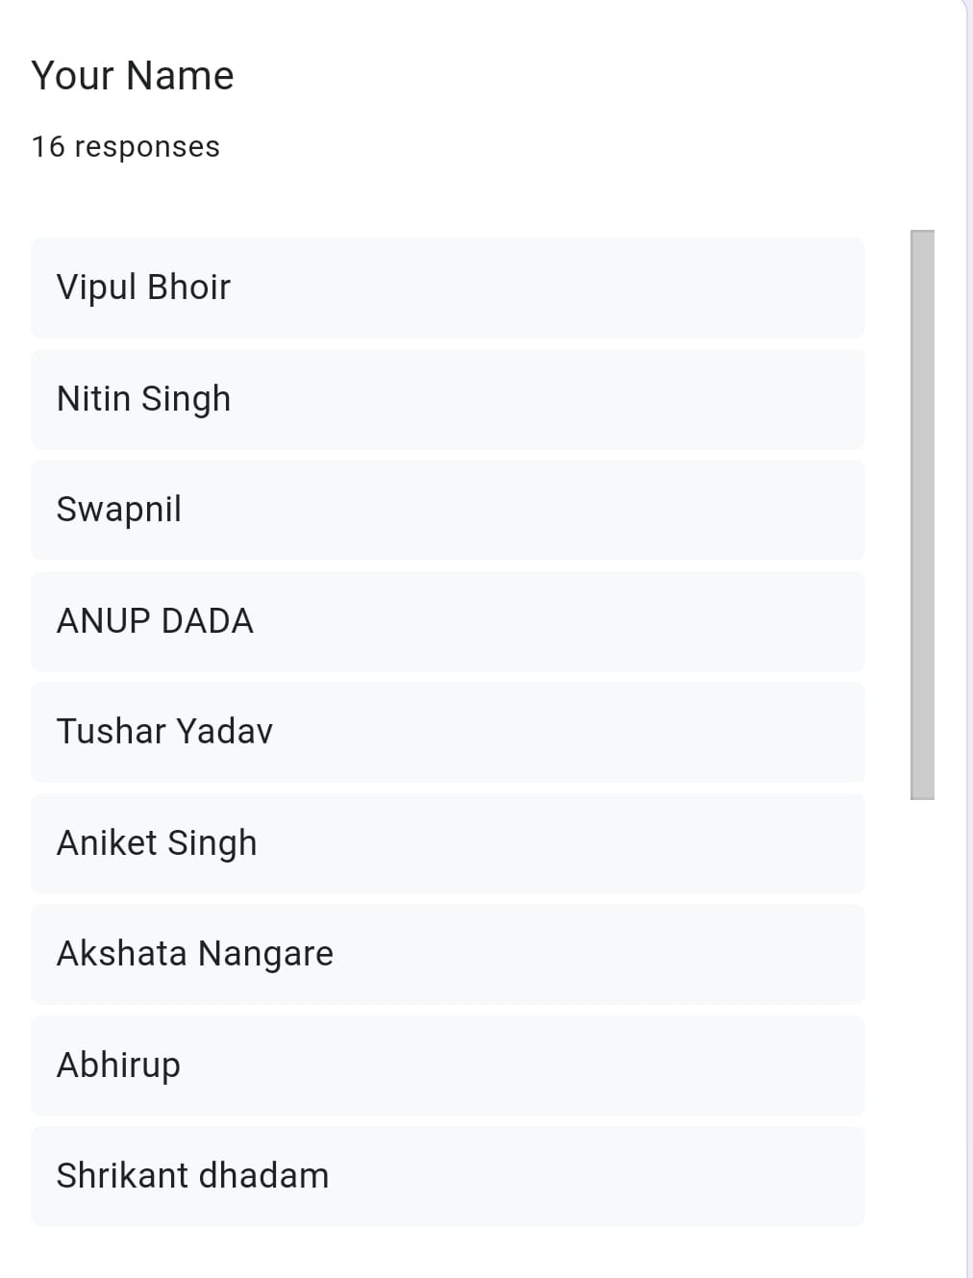

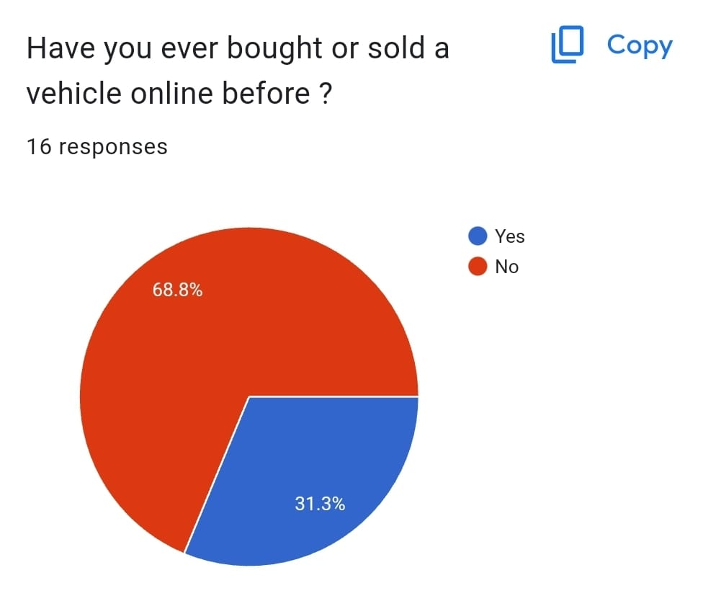

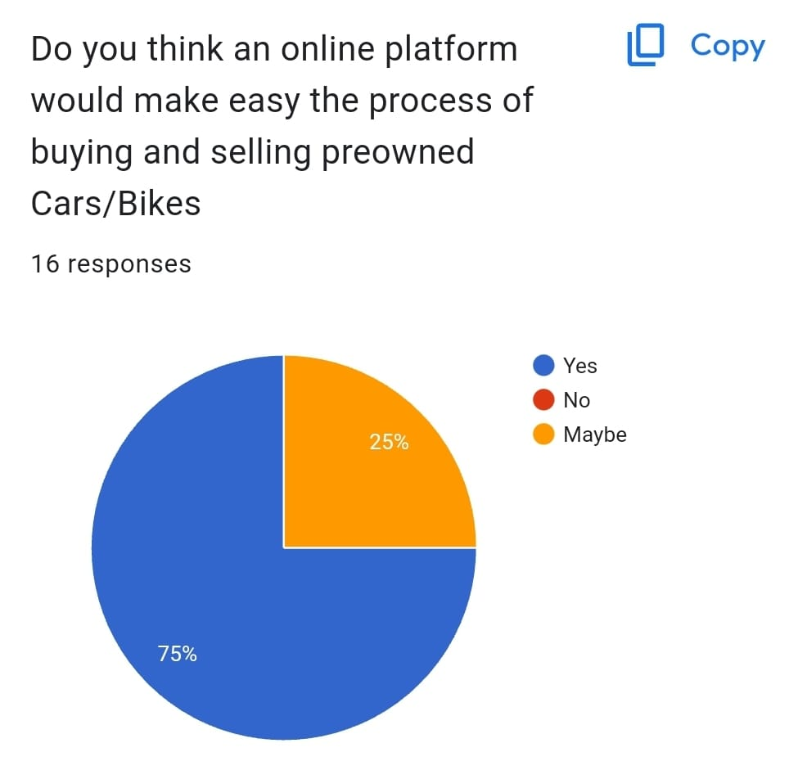

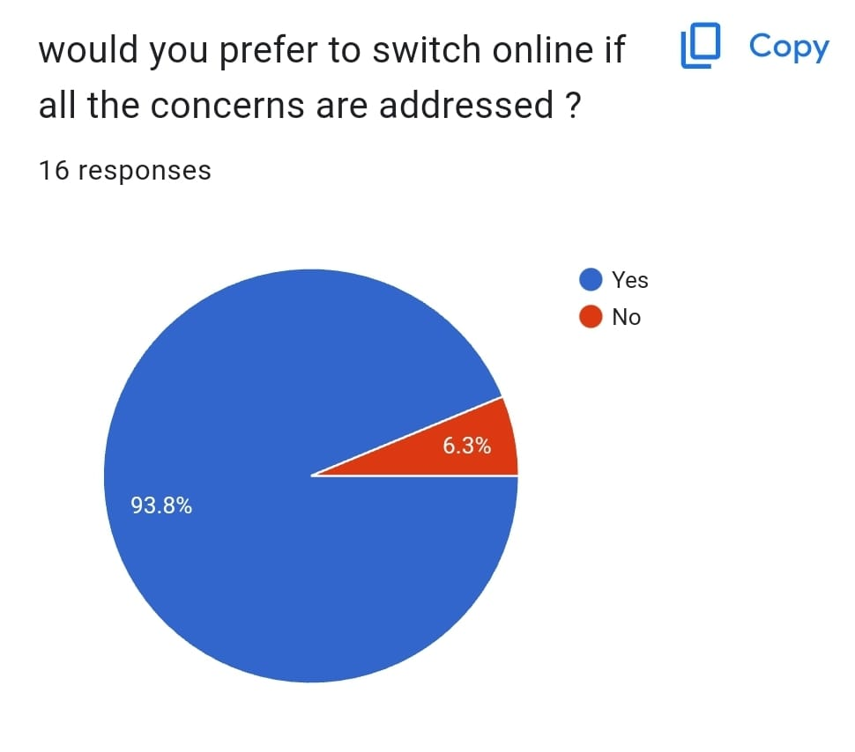

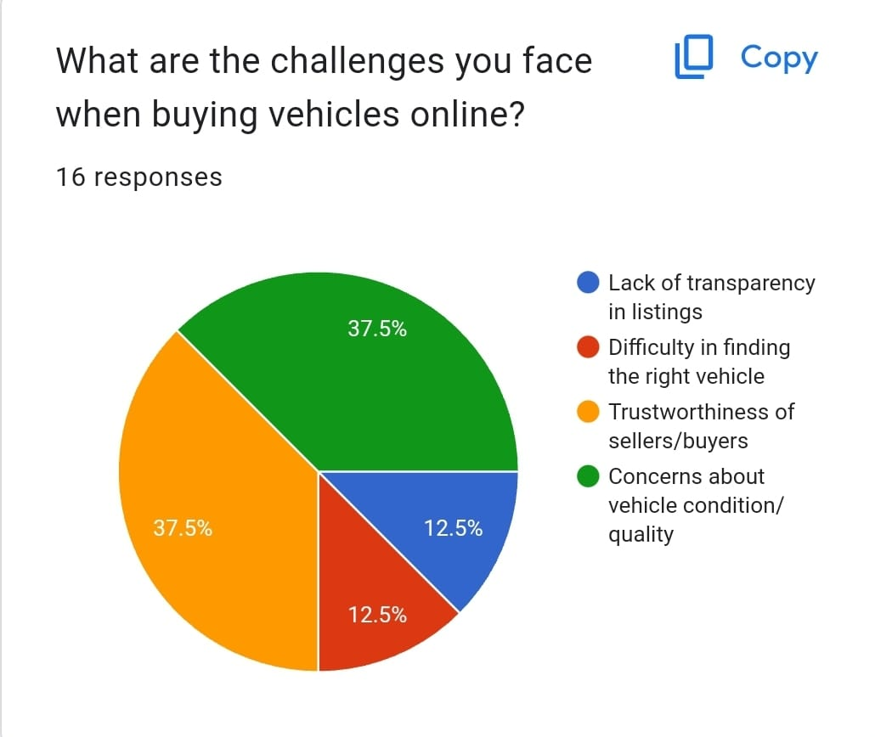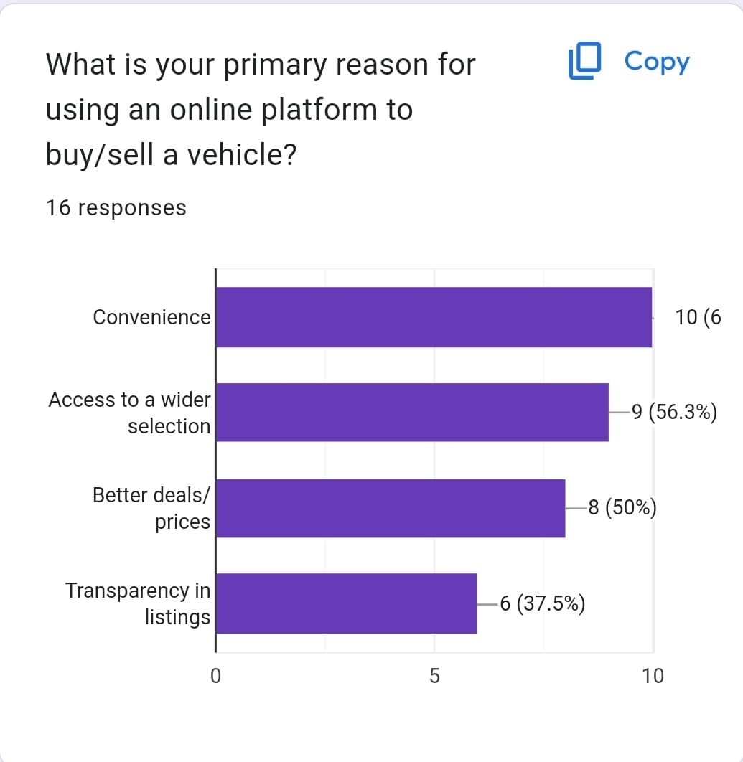

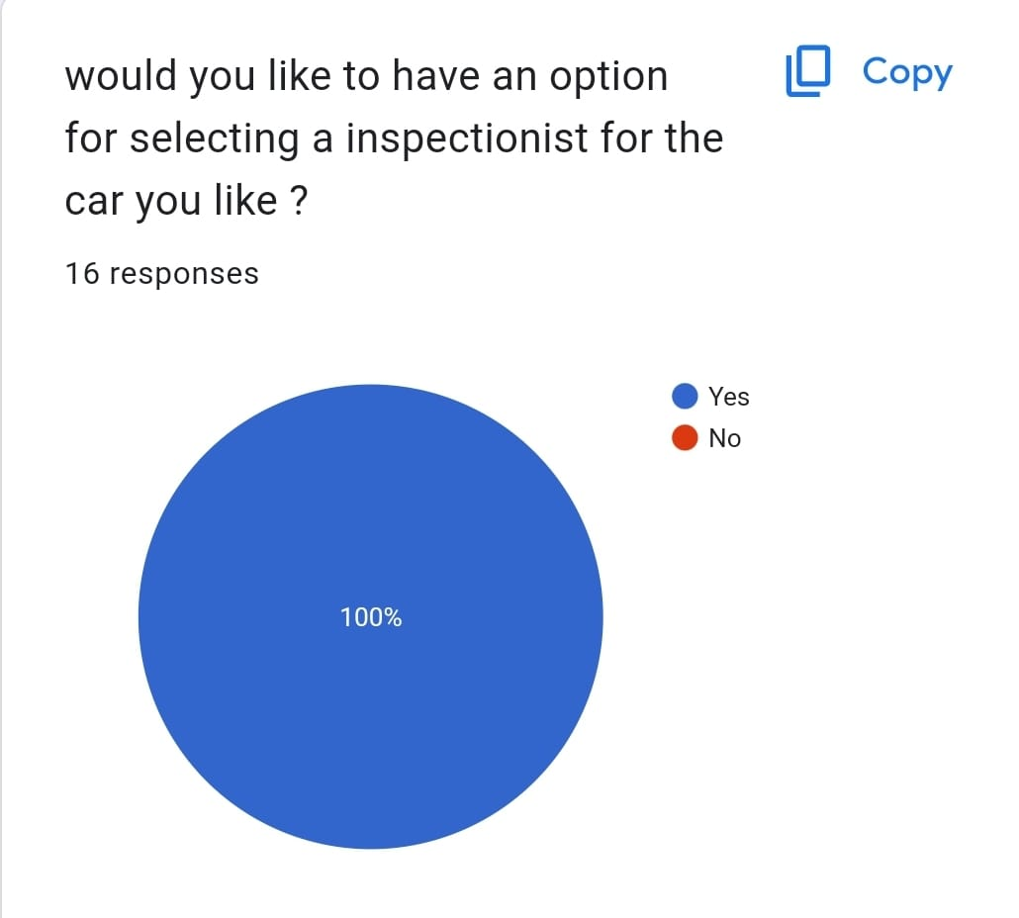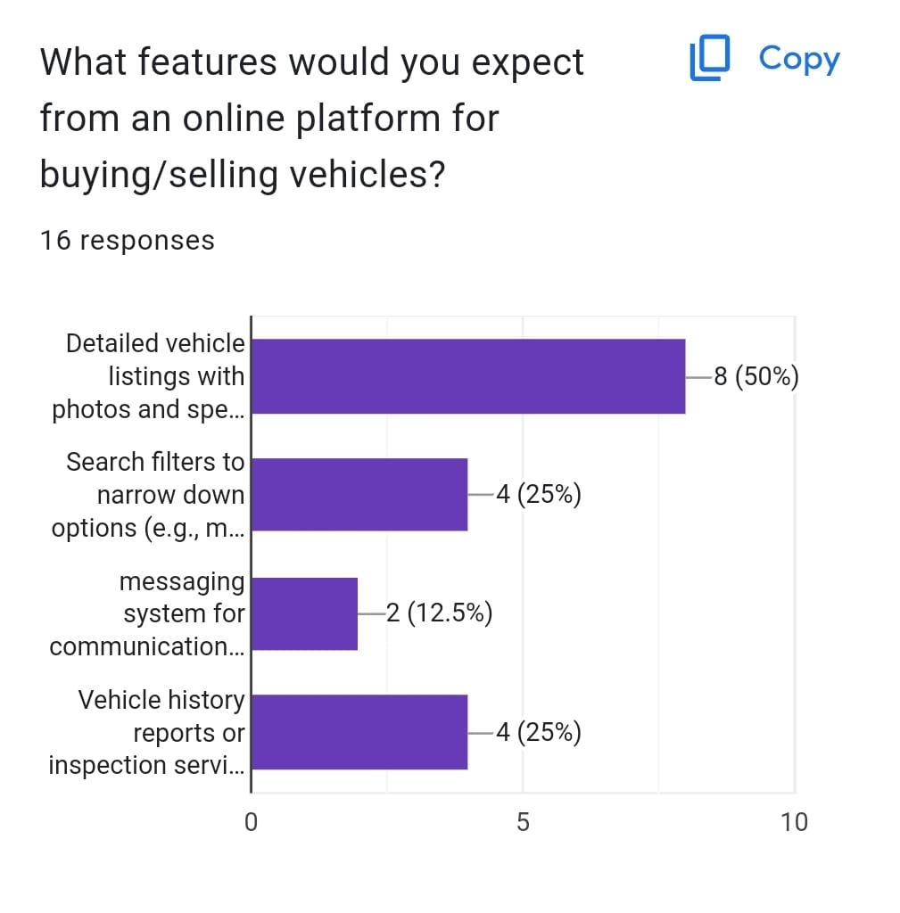

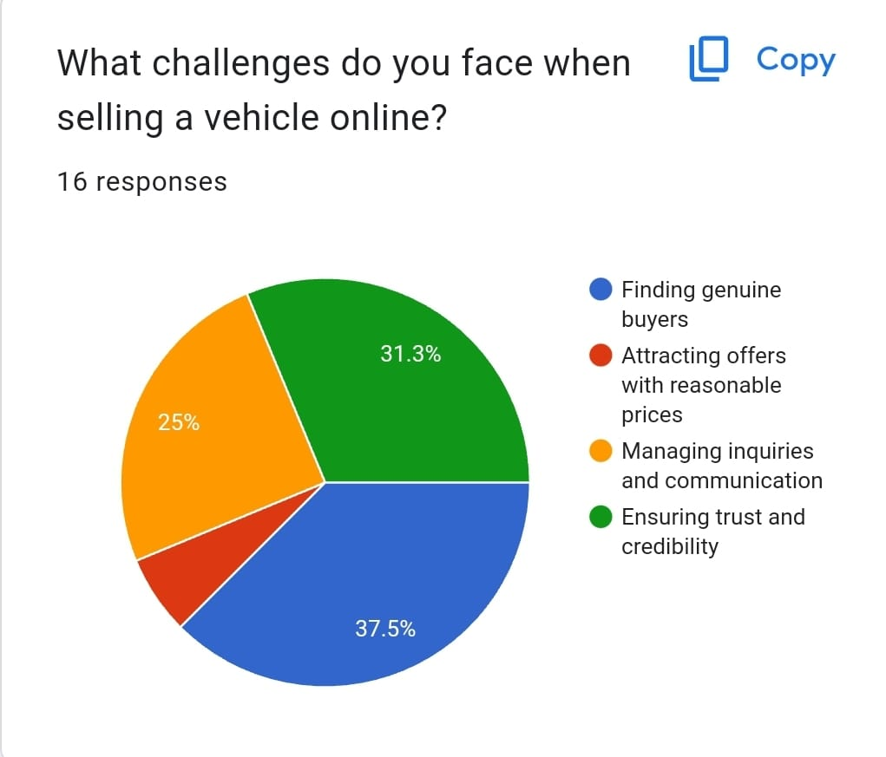

* + - Functional Requirements:-

1. **Registration/Login** :- The user is first required to register ive to create an account. It involves providing information like, email, username, password, etc. After registration, user can login using their chosen username and pass mered.
2. **Searching and filter**:- It allows Buyers for easily Searching and filter the listings according to their requirements.
3. **vehicle listing:-** The seller should be able to create Ads of their vehicles including the details like, vehicle history, high-quality images, videos, owner experience, images and description of damaged parts if any, specifications, etc.
4. **Inspectionist finder Tab**:- The buyer will be able to select an inspectionist to inspect the selected vehicle.
5. **Messaging**:- It allows users ie. Buyers and sellers. to chat and communicate with eachother.
6. **listing Management**:- It allows user to manage and edit vehicle Listing.
   * + Non-Functional Requirements:-
7. **User-Friendly interfaces** :- users. can easily and effectively interact with the user-friendly interfaces provided by website.
8. **Security**:- The system should verify the users according to their username and password. If the credentials matches then only the user will be logged in. So that the registered users can used the website and security will be maintained.
   * + System Requirements:-
9. **Registration/Creating account**:→

• The user must create an arrount [i.e do Registration] first to access the website.

* + - Input:- name, email, contact no, password, confirm password.
    - Source:- User.
    - Destination DataBase.
    - Output: Registration done successfully.
    - Action: After completeing Registration process user's account will be created.
    - pre-Condition: user should not have an account.
    - post-Condition: User can login using the username and password.

1. **Login**:-

* User can login the website using the username and password which is set by the user while creating the account.
* Input: username and Password.
* Source: user.
* Destination:
* output: login successfully.
* Action: when the user enters username and password. the data entered is checked whether it matches with the data present in DataBase. If it matches the user is redirected to homepage and if it desen't matches. then user have to enter the data again.
* Pre-condition: The user must have an account.
* Post-Condition: The user will be redirected to Homepage.

1. **listing Filter**:-

* User can use filter to shortlist vehicle listings and select the desired vehicle according to their requirements.
* Input:- user can select vehicle type, model, color, year, location, etc.
* Source:- User.
* Destination:-
* output:- listings will be displayed depending on the options selected by user.
* Action:- when the user selects options from filter like, vehicle type, year, location, color, etc. The selected. data is processed and listings are displayed according. to the selected options.
* pre-condition: user must select all the filter option.
* post-Condition: listings are displayed according to the options selected.

1. **Inspectionist finder Tab** :-

* If any user is interested in a vehicle and want to inspect the vehicle. User can celect the inspection ist to inspect vehicle.
* Input: The user can filter the inspectionists depending upon location and select them.
* Source:- Buyer.
* Destination:-
* output: list of inspectionists will be displayed according to selected location..
* Action:-when the Buyer selects the location. then the list of inspectionists will be displayed so that the Buyer can select the inspectionist to inspect the vehicle.
* Pre-Condition: Buyer must select the location.
* Post-Condition: list of inspectionists available at that location will be displayed.

1. **Ad Creation** :-

* Sellers can create Ad of their vehicle and list their Ad on website.
* Input:- user have to enter the vehicle details like vehicle history, features, specifications, images, videos, year, vehicle type, etc.
* Source: seller
* Destination Database.
* Output:- Ad created by the seller will be displayed. on the website.
* Action: seller have to fill the form and give the required information like, vehicle features, specifications, history, maintainance records, images, videos, etc.
* pre-Condition:- seller must give all the vehicle details.
* post-Condition:- Ad will be listed on the website.

1. **Ad modify**:-

* In case seller filled some wrong info in Ad creation. form or want to modify/ change Ad content. So seller can change it.
* Input: seller can refill the

Ad creation form and modify Content that is to be changed..

* Source: seller.
* Destination DataBase.
* output: The seller want's to change Ad content seller Can refill the Ad creation form and modify the content that will reflect in Ad listed on website.
* Action:- The content which is modified will automatically change in Ad.
* pre-condition: seller must have created Ad first.
* Post-Condition: The Content which is modified by the seller is updated in the Ad listed on website.

1. **forget Password** :-

* If any user forget's password and unables to login, then the user can reset the pass word.
* Input: email-id, otp.
* Source: user.
* Destination: Database.
* output: New password will be updated in DataBase.
* Action: when the user updates the password it will be updated in Database and then user can login with the mew password.
* Pre-condition: user must have an account.
* Post-Condition: new password is updated in DataBase and user can login with new password.